Serial Number: GOQRP8Y1FO56

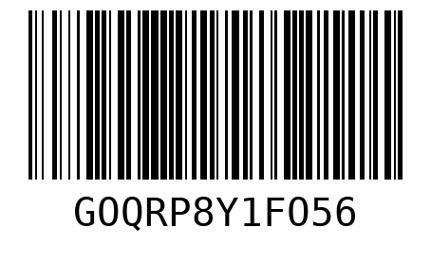

Serial Number: 8UODE3LDH9HX

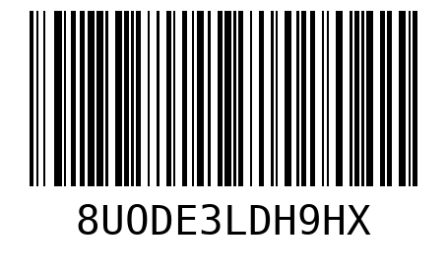

Serial Number: LA4Y9E7JQ3OD

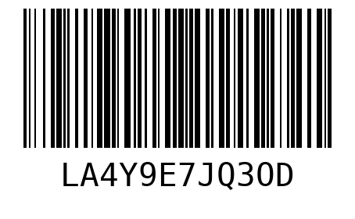

Serial Number: 44KP9V5KW21W

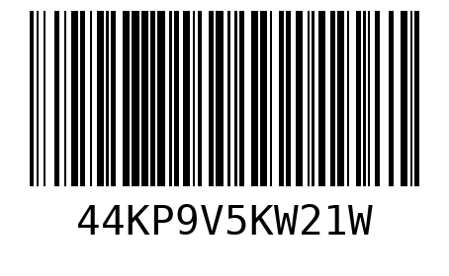

Serial Number: 0ZVD51WLYPPB

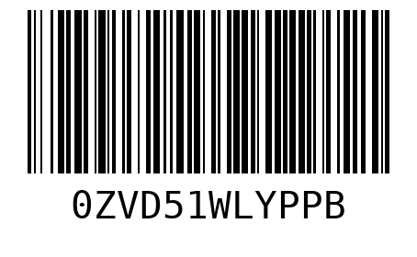

Serial Number: MKEEBCH7JFUQ

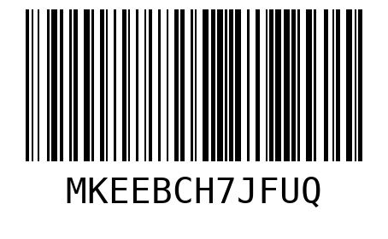

Serial Number: D61CSTM62VSI

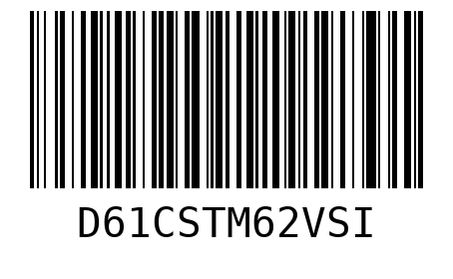

Serial Number: S13UKXC4M8EN

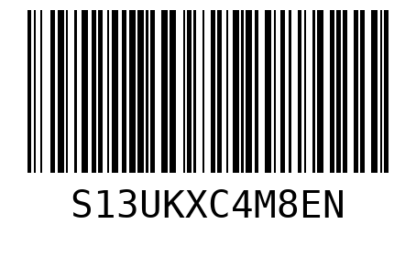

Serial Number: 2IUNRBG9VGZ5

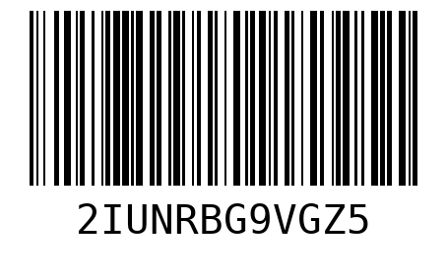

Serial Number: 0CMOGJMZQLZE

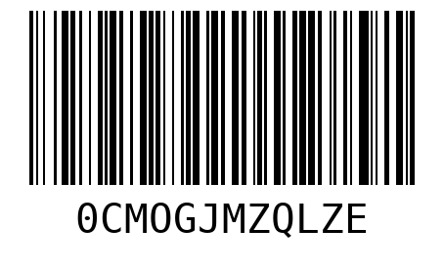

Serial Number: WW4OXJ7N70RD

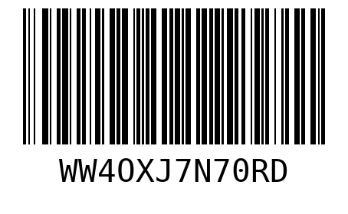

Serial Number: CRMEBDIPO82M

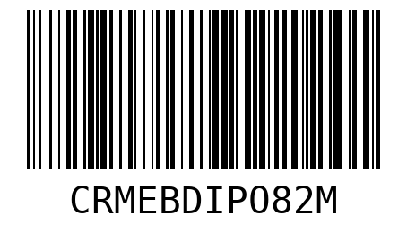

Serial Number: 6BTDNVSMYQHL

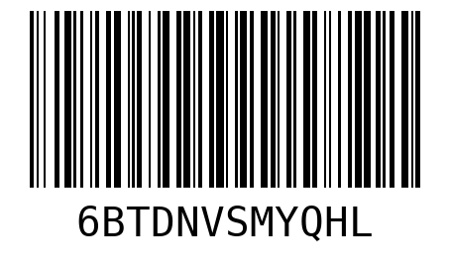

Serial Number: 78J79WMZ91UY

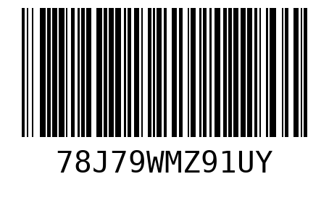

And then 1111

2222

3333

4444